**Objective**: Learning about some Oracle Constraints and know how to define constraint in different level.

**Types of data constraints:** There are two types of data constraints. One type is called I/O constraints and another type is business rule constraints.

I/O constraints is divided into two types. PRIMARY KEY constraints and FOREIGN KEY constraints.

**PRIMARY KEY Constraint:** A primary key is one or more column in a table used to uniquely identify each row in a table.

A primary key cannot be null. And data in that column must be unique.

We can define PRIMARY KEY in two way.

1. Column level
2. Table level

**PRIMARY KEY constraint defined at column level:**

**Syntax: <**column name> <datatype> (<size>) PRIMARY KEY

**Ex:** CREATE TABLE MBSTUStudent( id VARCHAR2(10) PRIMARY KEY,

name VARCHAR2(15),

dept VARCHAR2(12),

address VARCHAR2(10),

cgpa NUMBER(4));

**Output:**

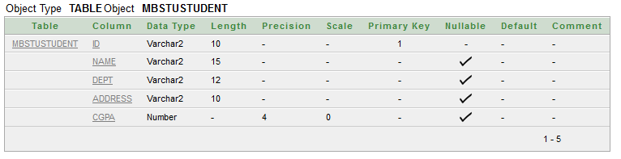

**PRIMARY KEY constraint defined at table level:**

**Syntax:** PRIMARY KEY (<column name>, <column name>)

**Ex:** CREATE TABLE MBSTUStudent( id VARCHAR2(10),

name VARCHAR2(15),

dept VARCHAR2(12),

address VARCHAR2(10),

cgpa NUMBER(4),

PRIMARY KEY(id));

**Output:**



**The FOREIGN KEY constraint:** Foreign keys represent relationships between tables. A foreign key is a column or a group of columns whose values are derived from the primary key or unique key of some other table.

**FOREIGN KEY constraint defined at the column level:**

**Syntax:** <columnName> <datatype> (<size>) REFERENCES <TableName>;

**Ex:** CREATE TABLE StudentInfo( id VARCHAR2(10) REFERENCES MBSTUSTUDENT,

age NUMBER(2),

phone VARCHAR2(14) PRIMARY KEY,

sessionYear varchar2(10));

**Output:**

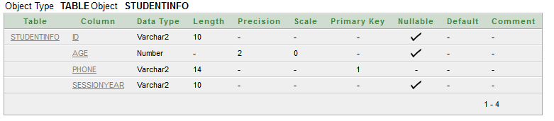

**FOREIGN KEY constraint defined at the table level:**

**Syntax:** FOREIGN KEY (<columnName>, <columnName>) REFERENCES <tableName> (<columnName>,<columnName>);

**Ex:** CREATE TABLE StudentInfo( id VARCHAR2(10),

age NUMBER(2),

phone VARCHAR2(14),

sessionYear varchar2(10),

PRIMARY KEY(phone),

FOREIGN KEY(id) REFERENCES MBSTUStudent);

**Output:**



**Custom Constraints:**

**Check:** Business rule validations can be applied to a table column by using CHECK constraint.

**Syntax:** <ColumnName> <DataType>(<size>) CHECK (<logical_expression>)

**Ex:** CREATE TABLE ITstudent( id VARCHAR2(10) CHECK(id LIKE 'IT%'),

name VARCHAR2(15) CHECK(name = UPPER(name)),

age NUMBER(2) CHECK(age BETWEEN 19 AND 23));

**Output:**

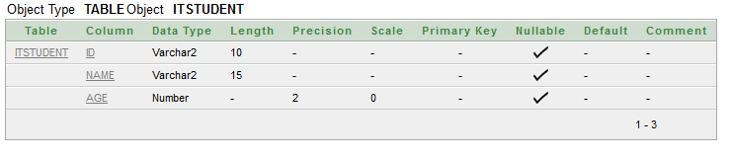

**Dropping integrity constraints via the ALTER Table command:**

**Syntax:** ALTER TABLE <TableName> DROP PRIMARY KEY;

**Ex:** ALTER TABLE STUDENTINFO DROP PRIMARY KEY;